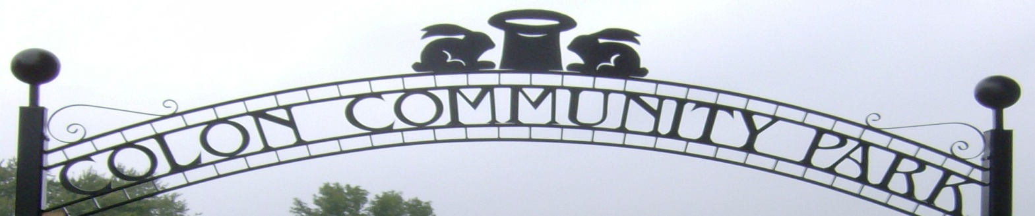

Buy a Brick
Coordinated by the Colon Community Parks Board

Engraved Brick of Your Own Design!
Become a permanent part of our beautiful community park. Buy a brick with the names of you or your loved ones. It will be placed in the pavilion courtyard by the flagpole. Bricks make great gifts for Mother’s and Father’s Day, weddings, anniversaries and other special occasions. Buy a brick and become a part of Colon’s History!

The standard bricks are red pavers that come in 4”x 8” and 8”x 8” sizes and are 2¼” thick. An exclusive laser process guaranteed for the life of the brick is used to indelibly engrave these bricks. Ask about pricing on specialty brick designs that can even have graphics, like company logos or clip art.

Donation: $50 – 4 x 8 brick $100 – 8x 8 brick Circle One

Engraving Information
Use the boxes below to enter up to 20 characters/numbers per line, including spaces and punctuation. The 4 x 8 bricks can have 3 lines of wording and the 8 x 8 up to 6 lines of wording. Each line will be automatically centered horizontally.

Lines 1-3 (4 x 8 and 8 x 8 bricks)

Lines 4-6 (8 x 8 Brick only)

Name _________________________________
Address ________________________________
City ________________________ State ______ ZIP _______
Phone __________________Email______________________

Make out checks to the Colon Community Park Brick Fund. Mail to. P.O. Box 50 Colon MI 49040 or drop off at the Colon Village Hall. Questions? (269)432-2532

The form can also be found on the www.colonmi.net web site under the Buy-A-Brick Campaign link.
We reserve the right to reject any inappropriate wording 08/2020

